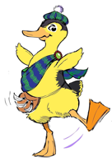
WIGTOWN AGRICULTURAL SOCIETY
OPEN POULTRY SHOW

AFFILIATED TO THE NATIONAL FEDERATION OF POULTRY CLUBS

WEDNESDAY 2nd AUGUST 2023
AT BLADNOCH PARK, WIGTOWN
Sat Nav: DG8 9AB

NO LIVE BIRDS AT THE SHOW

JUDGES

Photography- Emma Murdoch
Painting/Drawing &Greetings Cards -Emily Nash
Handicrafts-Elizabeth Wallace
Floral Art -Claire Nash
Poultry – Clare Beebe
Eggs – Graham Hicks

Prizes

BEST IN SHOW £20 RESERVE £15
Trophies, Rosettes and Chapman Cards

ALL POULTRY SHOW ENTRIES CLOSE: SATURDAY 22nd JULY 2023

Entries to:
Wigtown Poultry Show Secretary
Miss Rosslyn Wilson, Baryerrock Farm, Whauphill, Newton Stewart, DG8 9PB
Telephone: 07710846552 Email: roz0425@outlook.com
Sponsors
The Wigtown Poultry Show Committee is extremely grateful to sponsors who help make the show possible. A big thank you to the following for sponsorship towards the 2023 Show:
All at Apple Cottage
Dundas Chemical Company, Tel:01387 252887
Newton Stewart & District Round Table
Newton Stewart Initiative
Phoenix Electrical, Tel:01671 404 091
Rosslyn Wilson
Solway Recycling Limited
Wigtown Community Shop, 34 South Main Street, Wigtown

Robert Sherry is proud to sponsor
The Wigtown Poultry Show
Championship Row 2023
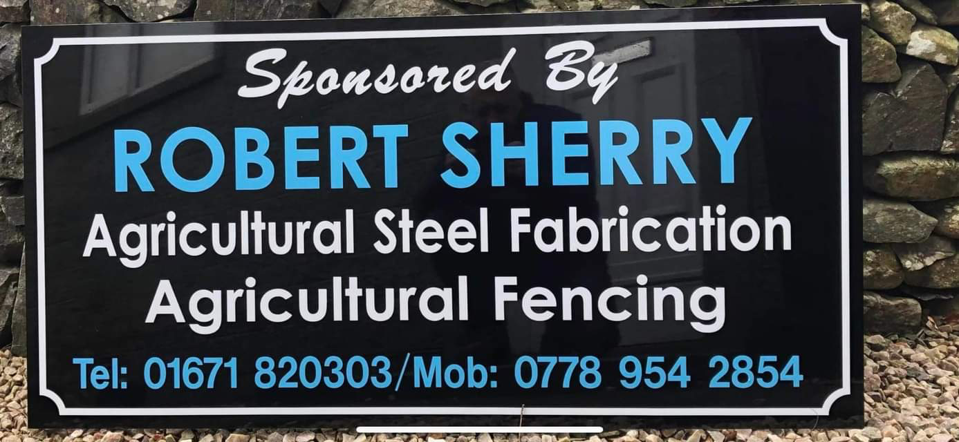

RULES & CONDITIONS FOR ALL EXHIBITORS
The Wigtown Poultry Show is held under WIGTOWN AGRICULTURAL SOCIETY RULES and exhibitors making entries agree to be bound by such rules.
Whilst every care will be taken to ensure that exhibits are safe during the show, neither Wigtown Agricultural Society Nor the NFC shall be held liable for any loss/damage to eggs or exhibits during the show.
- Classes may be amalgamated or split if deemed necessary
- Junior &Juvenile and Wigtownshire exhibitors MUST mark their AGE clearly on entry form.
- More than 1 entry may be made in each class.
- If any judge is unable to officiate, we reserve the right to appoint a substitute.
- The judge’s decision is final.
- Any complaint about an exhibitor or judging must be made in writing on the day and handed to the Poultry Secretary with a deposit of £20, which will be forfeited should the Poultry Show Committee deem the protest to have been made without reasonable grounds.
- All eggs entered must be from exhibitors own birds, with the exception displayed and the painted and decorated egg classes

No late/phone entries accepted. Entries close Sat 22nd July 2023

ENTRY FEES:
£1 per entry

Poultry Marquee –Open for penning from 6.00 pm – 9.00 pm Tuesday 1st August 2023
6.30 am – 9.00 am Wednesday 2nd August 2023

Judging 9:15 am

Anyone with other livestock that have to leave the show ground before 4:30 pm should arrange that the penning slip authorises their alternative collection at 4:30pm
All eggs to be removed by 4:45 pm

Poultry Classes Rules For 2023
- The birds must be prepared for showing and the best possible photograph taken of it to be exhibited.
- The photograph should be 13cmx18cm(7”x5”) unmounted.
- The photograph should be taken looking side on to the bird so that most of the bird can be viewed.
- In the corner of the photograph a can of Irn-Bru should be placed to the show the picture has been taken for this year’s Wigtown Poultry Show.

EGG Exhibits

Exhibitors can carefully post their eggs exhibits to the Secretary of Wigtown Poultry Show four days prior to the show if you are unable to attend.

Our photographer this year in the Marquee:
Emma Louise Photography.
Please check out her Facebook Page

If you would not like your photo or name to be on Facebook or Newspaper please let the Secretary of the Wigtown Poultry Show know.
Poultry Classes
Pet Section
- AV (L/F) M
- AV (L/F) F
- AV Bantam M
- AV Bantam F
- AV Waterfowl M
- AV Waterfowl F

Open Junior (10 years and Under)
- AV Large Fowl M/F
- AV Bantam S/F M/F
- AV Bantam H/F M/F
- AV True Bantam M/F
- AV Waterfowl M/F
- AV Pet M/F

Open Juvenile (11-16 years)
- AV Large Fowl M/F
- AV Bantam S/F M/F
- AV Bantam H/F M/F
- AV True Bantam M/F
- AV Waterfowl M/F
- AV Pet M/F

Wigtownshire Residents
- Large Fowl S/F M/F
- Large Fowl H/F M/F
- Bantam S/F M/F
- Bantam H/F M/F
- True Bantam M/F
- Large Fowl Pet M/F
- Bantam Pet M/F
- Large Fowl Hybrid M/F
- AV Waterfowl M/F
- AOV M/F

Eggs
- 6 Eggs- AC Large Fowl
- 6 Eggs- AC Bantams
- 6 Eggs -AC Duck
- 3 Large- Marans
- 3 Large - Welsummer
- 3 Large - AOV Brown
- 3 Large - White
- 3 Large - Cream
- 3 Large - Araucana
- 3 large - AOC
- 3 Large - Distinct Colours
- 1 Large – Marans
- 1 Large- Welsummer
- 1 Large- AOV Brown
- 1 Large- White
- 1 Large- Cream
- 1 Large- Araucana
- 1 Large- AOC
- 3 Bantam- Marans
- 3 Bantam- Welsummer
- 3 Bantam- AOV Brown
- 3 Bantam- White
- 3 Bantam- Cream
- 3 Bantam- Araucana
- 3 Bantam- AOC
- 3 Bantam- Distinct Colours
- 1 Bantam- Marans
- 1 Bantam- Welsummer
- 1 Bantam- AOV Brown
- 1 Bantam- White
- 1 Bantam- Cream
- 1 Bantam- Araucana
- 1 Bantam- AOC
- 3 Duck- AC
- 1 Duck- AC
- 3 Goose
- 1 Goose
- 3Turkey
- 1 Turkey
- 3 AOV
- 1 AOV

Eggs-Continued

- Junior Wigtownshire Resident
3 Any 1 Variety L/F or Bantam
- Juvenile Wigtownshire Resident.
3 Any 1 Variety L/F or Bantam
- 1 Contents- Large Fowl
- 1 Contents- Bantam
- 1 Contents- Waterfowl
- 1 Contents- Turkey
- 1 Contents- AOV
- 1 AC Large Fowl External & Internal
- 1 AC Bantam External & Internal
- 1 AOV External &Internal
- 1 Large Fowl Egg &
1 Bantam Egg Matching (Same Breed)
- 1 Unusual Shaped Egg

Eggs Decorated/ Hand Painted

- 1 Decorated Egg 10 years &Under
- 1 Decorated Egg 11 -16 years
- 1 Decorated Egg Open
- 1 Hand-Painted Egg 10 years &Under
- 1 Hand -Painted Egg 11 - 16 years
- 1 Hand -Painted Egg Open

All Decorated & Painted eggs to be themed on one of the following:

Farmyard
Bonnie Galloway

Open Junior Eggs (10 Years& Under)

- 1 Large- Any Colour
- 3 Large- Any Single Colour
- 1 Bantam-Any Colour
- 3 Bantam- Any Single Colour
- 1 AOV
- 3 AO Single Variety
- 1 Contents –Any Size/ Variety

Open Juvenile Eggs (11 - 16 Years)

- 1 Large- Any Colour
- 3 Large- Any Single Colour
- 1 Bantam-Any Colour
- 3 Bantam- Any Single Colour
- 1 AOV
- 3 AO Single Variety
- 1 Contents –Any Size/ Variety

Photography

- Portrait of any species of poultry 10 years& under
- Portrait of any species of poultry 11-16 years
- Portrait of any species of poultry Open

- A scene to include poultry 10 years & under
- A scene to include poultry 11-16 years
- A scene to include poultry Open

- A photo of or to include eggs 10 years & under
- A photo of or to include eggs 11-16 years
- A photo of or to include eggs Open

- A photo of chicks or ducklings 10 years& under
- A photo of chicks or ducklings 11-16 years
- A photo of chicks or ducklings Open

- A poultry photo with a caption 10 years & under
- A poultry photo with a caption 11-16 years
- A poultry photo with a caption Open

Photography classes
Poultry to include:large fowl, bantams, ducks, geese, turkeys, quail, guinea fowl.
All photographs to be size 13cmx 18cm (7” x5”and unmounted)

Painting Or Drawings

- A scene with poultry 10 years & under
- A scene with poultry 11 - 16 years
- A scene with poultry Open

- A Painting of chicks, ducklings, goslings or turkey poultry 10 years& under
- A Painting of chicks, ducklings, goslings or turkey poultry 11-16 years
- A Painting of chicks, ducklings, goslings or turkey poultry Open

All paintings or drawings to be A4 and may be in any medium e.g water colours, oils, crayons etc.
The photographs, paintings and greeting cards will be exhibited on upright display boards
Exhibits should not have won a prize at a previous Wigtown Poultry Showing
Greetings Cards

- Thank you 10 years& under
- Thank you 11 - 16 years
- Thank you Open

- Get Well Soon 10 years& under
- Get Well Soon 11 - 16 years
- Get Well Soon Open

All greetings cards to be no larger than A5 (23cm x 16 cm). Decoration in any medium or style but must be on a poultry theme and include at least one real feather

Handicrafts
- Any item of handicraft with a poultry theme 10 years & under
- Any item of handicraft with a poultry theme 11 - 16 years
- Any item of handicraft with a poultry theme Open

Please indicate what your entry is on the entry form to help space allocation
- A decorated pair of sunglasses on a poultry theme 10 years& under
- A decorated pair of sunglasses on a poultry theme 11-16 years
- A decorated pair of sunglasses on a poultry theme Open

Headbands to be exhibited on mannequin heads which are provided
- A knitted garment with a poultry theme Open
- A crocheted item with a poultry theme Open

Class 135and class 136 will be split if young age groups enter

- A species of poultry made from fruit or veg 10 years& under
- A species of poultry made from fruit or veg 11-16 years
- A species of poultry made from fruit or veg Open

- Caution free range chickens sign 10 years & under
- Caution free range chickens sign 11-16 years
- Caution free range chickens sign Open

- A painted stone paper weight on a poultry theme 10 years& under
- A painted stone paper weight on a poultry theme 11-16 years
- A painted stone paper weight on a poultry theme Open

- A decorated wooden spoon on a poultry theme 10 years & under
- A decorated wooden spoon on a poultry theme 11-16 years
- A decorated wooden spoon on a poultry theme Open

Floral Art

- A flower arrangement in a poultry mug 10 years & under
- A flower arrangement in a poultry mug 11 - 16 years
- A flower arrangement in a poultry mug Open

Space allowed 18”x18”

- An arrangement to include eggs 10 years& under
- An arrangement to include eggs 11 - 16 years
- An arrangement to include eggs Open

Space allowed 24”x24”

- An arrangement to include ducklings or chicks 10 years& under
- An arrangement to include ducklings or chicks 11 - 16 years
- An arrangement to include ducklings or chicks Open

Space allowed 24”x24”

Classes 149-157 accessories and drapes allowed
CUPS PRESENTED

Show Champion
Reserve Champion
Best Wigtownshire Junior
Best Wigtownshire Juvenile
Best Wigtownshire Senior
Best Wigtownshire
Best Open Junior
Best Open Juvenile
Best Pet
Best Junior Eggs

Best Juvenile Eggs
Best Eggs
Best Decorated/ Painted Egg
Best Photograph
Best Greetings Cards
Best Painting/Drawing
Best Handicraft
Best Floral Art

CUPS NOT PRESENTED

Junior Wigtownshire Eggs
Juvenile Wigtownshire Eggs
Novice Junior
Novice Juvenile
Wigtownshire Novice

Junior Most Points
Juvenile Most points
Senior Most Points
People’s Choice Award
Furtherest Travelled

